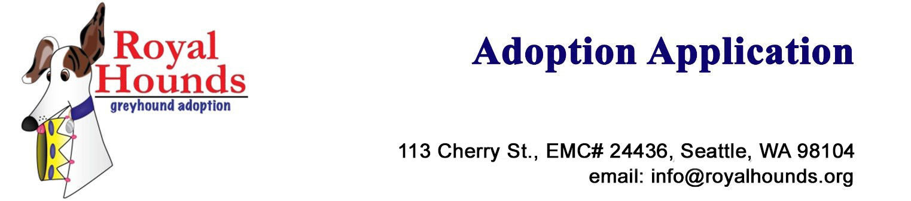

At Royal Hounds Greyhound Adoption our goal is to place greyhounds into homes that will benefit both the dog and the pet owner. Please answer the following questions with as much detail and honesty as possible. Return this form to your local Royal Hounds Greyhound Adoption Representative or email it to info@royalhounds.org. Please note that a non-refundable $50 deposit will be required to order or hold a dog. This amount will be applied to your adoption fee (also not refundable). If we decline your application your deposit will be refunded.

Some important things to know about adopting a greyhound from RHGA

- Greyhounds are indoor pets. With their low body fat they are sensitive to both heat and cold.
- A greyhound can never be staked or tied. They have great power and speed so reaching the end of the chain would be devastating.
- Greyhounds need to be on a leash or in a fenced area. They enjoy chasing anything including squirrels, leaves and paper bags. They are very focused and travel great distances very quickly. Because of this they aren’t good at finding their way home and even if well trained they can be out of hearing range before you can even call to them.
- Greyhounds typically need to be let outside 4 to 6 times per day. A new greyhound learning about home life will need to go out every couple of hours.
- Some greyhounds prefer to have their own crate; you may need to have one at least to begin with.
- The greyhound’s racing career is over and it cannot be reactivated.
- If for any reason you’re unable to keep your greyhound he or she needs to be returned to RHGA and cannot be sold or given away.
- All members of the household need to be in total agreement about adopting a greyhound.

I have read the above: Initial Here. (Initial)

©Royal Hounds Greyhound Adoption
Application

☐ I want to Adopt
☐ I want to Foster

- Do you have a fully fenced yard with a fence that is at least 4’ high? ☐ Yes ☐ No
- Have you previously owned a greyhound? ☐ Yes ☐ No

NOTE: If you do not have a fenced yard and have not previously owned a greyhound we can put you on a wait list for a greyhound that we believe can succeed in an apartment or home without a fenced yard. Typically these are dogs that have previously lived in a home and have been returned to RHGA.

- If you would like to be placed on the wait list check yes and continue with the application.
☐ Yes ☐ No

Personal Information

Name & Age:  Enter Name / Age Here | Spouse / Partner Name & Age:  Enter Name / Age Here
Occupation: Enter Occupation Here | Occupation: Enter Occupation Here
Primary Phone #: Phone # | Secondary Phone #: Phone #
Address: Enter Address, City, State & Zip
Email Address(s):  Enter Email Address | Emergency Contact:  Enter Name, Address & Phone

Tell us a little bit about your home:

Number of adults in the household:  Enter number of adults | Hours someone is at home:  Enter hours
Number of children in the household & their ages:  Enter children | Does any member of the family have special needs? (If yes, please explain)  Enter special needs
Type of dwelling: (condo, apartment, house)  Enter type of dwelling | Do rent or own your home?  ☐ Rent ☐ Own
If renting, do you have permission from the landlord and/or does your lease allow you to have a large dog?  ☐ Yes ☐ No ☐ N/A | If renting, landlord’s name and phone number:  Enter landlord
Do you have a fully fenced yard?  ☐ Yes ☐ No | Type of fencing and height?  Enter type of fencing and height
Is there anything you can tell us about your lifestyle that will assist us in selecting the best greyhound for your home?

Enter lifestyle information

Your Pets and Experience:

If you currently own pets please tell us about them and how they were obtained. (breed, temperament, sex, age, etc.)

Enter info on current pets
Do you have any pets under 30 pounds (cats, small dogs), or any intention of getting any?
Enter info on small animals in the home
If you have had pets in the past where are they now?
Enter info on your past pets
Have you ever had to give up a pet for any reason, and if so, why?
Enter info here
Do you have a veterinarian?  ☐ Yes ☐ No  If yes, please provide the name, address and phone.  Enter Vet info | Do you consider yourself dog savvy?  ☐ Yes ☐ No  Enter any additional info
Some Basic Agreements:
Do you agree to a home visit with a RHGA representative for the purpose of answering your questions, providing a greyhound orientation and discussing any challenges your home may have for a greyhound?

☐ Yes ☐ No
If your lifestyle or environment changes will you make every effort to keep the dog?

☐ Yes ☐ No
Do you agree to notify RHGA if for any reason you are unable to keep your greyhound and agree that you will not give away or sell the greyhound, but return the greyhound to RHGA?

☐ Yes ☐ No
Do you agree to keep a tag collar bearing RHGA identification and your personal identification on the greyhound at all times?

☐ Yes ☐ No
Do you agree to keep your greyhound solely as a pet and never use it for research, racing or hunting of any kind?

☐ Yes ☐ No
Are all members of the household in total agreement about adopting a greyhound?

☐ Yes ☐ No

References:

Please provide 2 references (name, address & phone)  Enter reference #1 | Enter reference #2

Misc:

Where did you hear about Royal Hounds (Please be specific if you can, which pet store, market, website, etc.)
Enter where you heard about RHGA here

I hereby certify that all the information contained in this greyhound adoption application is true and accurate.

Signature: Signature Here Date: Select a date
This section is to better acquaint you with our volunteer system:
RHGA is comprised solely of volunteers and funded by donations. Please consider donating or giving a few hours to help us find homes for these wonderful dogs.

We have many talented volunteers. Are there ways you can help more greyhounds get to their forever homes?

Would you be willing to promote greyhound adoption at a local Meet and Greet?
☐ Yes ☐ No ☐ Maybe

Enter comments:
Would you be willing to help out with or plan special events? (picnics, fundraisers, auctions, etc.)
☐ Yes ☐ No ☐ Maybe

Enter comments:

Would you like to learn more about our foster program?
☐ Yes ☐ No ☐ Maybe

Enter comments:

Are you interested in fostering in the future?
☐ Yes ☐ No ☐ Maybe

Enter comments:

Would you like to be a temporary foster home for vacations or in an emergency?
☐ Yes ☐ No ☐ Maybe

Enter comments:

Do you have experience with fundraising, grant writing, etc.?
☐ Yes ☐ No
Everyone has a talent we can use. How would you like to help? What are your special talents?
Enter comments:

Contact Information
Name:  Enter your Name | Email:  Enter your email | Phone:  Enter your phone

©Royal Hounds Greyhound Adoption

